CIE
COPYRIGH INFORMATION EXTRACTION FORM

TITLE : Secure Online Examination System using AI Proctoring
SCHOOL: Chitkara University Institute of Engineering and Technology, Punjab

DETAIL OF THE STUDENT/MENTOR WHO UPLOADED THE COPYRIGHT ON GOVT PORTAL NEED TO SHARE LOGIN AND PASSWORD WITH MENTORS

Name: Dilpreet Singh
Roll No/ Employee Code: 2210991516

All MEMBERS DETAILS INCLUDING SUPERVISOR
NAME | EMP CODE/ROLL | ADDRESS WITH EMAIL AND MOBILE NO.
Dilpreet Singh | 2210991516 | Chitkara University, Punjab, 9816914953
Sunaina | 2210990875 | Chitkara University, Punjab, 7986693034
Kartik Thakur | 2210991760 | Chitkara University, Punjab, 7876617774
DR. ISHA KANSAL | CET1001265 | Chitkara University, Punjab, isha.kansal@chitkara.edu.in

Abstract:
The rapid evolution of digital education has significantly increased the demand for reliable and secure online examination systems. However, conventional online assessment platforms lack robust mechanisms to prevent cheating and ensure academic integrity. This project proposes a Secure Online Examination System integrated with AI-based proctoring that leverages advanced technologies such as computer vision, machine learning, and real-time monitoring to detect and prevent malpractice.
The system continuously analyzes candidate behavior through webcam and microphone inputs to identify anomalies such as multiple face detection, absence from screen, unusual head or eye movements, and background disturbances. It generates real-time alerts and records evidence for post-exam review. The proposed system ensures a fair, transparent, scalable, and cost-effective solution suitable for modern educational institutions and remote learning environments.

Background/Introduction:
With the global shift toward online learning, especially accelerated by events like the COVID-19 pandemic, educational institutions face significant challenges in conducting secure and credible examinations remotely. Traditional methods of invigilation are either resource-intensive or ineffective in a virtual environment.
Existing online exam systems primarily depend on trust or limited monitoring, making them vulnerable to cheating practices such as impersonation, use of unauthorized materials, and collaboration with others. Artificial Intelligence, particularly in the domains of computer vision and behavioral analytics, provides a powerful solution to automate proctoring tasks.
By integrating AI into online examinations, institutions can achieve real-time monitoring, automated anomaly detection, identity verification, and evidence-based evaluation. This project aims to bridge the gap between accessibility and security in digital assessments.

Objectives:
The primary objective of this project is to design and develop a secure and intelligent online examination platform that integrates AI-based proctoring mechanisms to ensure fairness and transparency in assessments. The system aims to authenticate candidates using facial recognition techniques, monitor their behavior continuously through video and audio analysis, and detect suspicious activities such as tab switching, multiple face presence, and abnormal movements. Additionally, it seeks to record and store examination sessions for audit purposes, generate automated alerts and logs for administrative review, reduce reliance on manual invigilation, and ensure data privacy through secure authentication and encryption techniques. The system is also designed to be scalable so that it can handle a large number of users simultaneously without performance degradation.

Proposed Solution / System Overview:
The proposed system is a web-based platform that combines an online examination interface with an AI-powered proctoring engine to provide a comprehensive solution for secure assessments. Users begin by registering and logging into the system through a secure authentication process, followed by identity verification using facial recognition technology. Once the examination starts, the system continuously captures and processes video and audio streams from the candidate’s device. Advanced AI algorithms analyze these inputs in real time to detect patterns such as eye gaze direction, head movement, and background noise, which may indicate potential cheating attempts. The system also monitors browser activity to identify actions like tab switching or accessing unauthorized resources. Any suspicious activity triggers immediate alerts and is logged with timestamps, while the entire session is recorded and securely stored for post-examination analysis. An administrative dashboard enables instructors to monitor live sessions, review flagged events, and generate detailed reports, ensuring a transparent and efficient examination process.

Key Features / Functionality
- Secure user authentication and role-based access control
- Facial recognition for identity verification
- Continuous live video and audio monitoring
- Detection of eye and head movements
- Identification of multiple faces in the frame
- Tracking of browser activity to prevent tab switching
- Automated alert generation and logging for suspicious activities
- Session recording for evidence collection
- Centralized administrative dashboard for monitoring and reporting
- Secure examination interface with restrictions on:
  - Copying
  - Pasting
  - Accessing external resources

Technology / Methods Used
- Frontend Development
  - Built using React.js for dynamic UI
  - Styled with Tailwind CSS for responsive design
- Backend Development
  - Implemented using Node.js
  - Uses Express.js for server-side logic and API handling
- Database
  - MongoDB used for storing user data, Examination records, activity logs
- Artificial Intelligence
  - OpenCV for image processing (face detection, movement tracking)
  - TensorFlow for machine learning model development and inference
- Real-Time Communications
  - Socket.io for Live monitoring and Instant alert generation
- Cloud Storage
  - Cloudinary / AWS used for secure storage of recorded media
- Authentication & Security
  - JWT (JSON Web Tokens) for secure session management
  - HTTPS protocols for secure data transmission
  - Data encryption to protect sensitive information

System Architecture

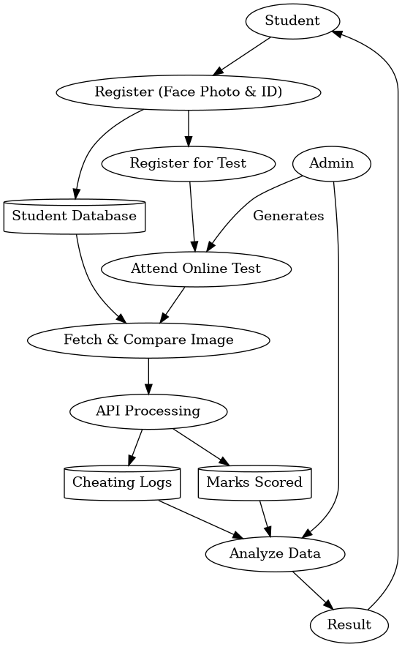

Expected Outcome & Benefits
- Enhances credibility and effectiveness of online examinations
- Ensures fairness and transparency in the assessment process
- Reduces cheating and malpractice through continuous monitoring
- Uses automated detection mechanisms to identify suspicious activities
- Minimizes the need for manual invigilation
- Helps in reducing operational costs
- Offers high scalability to support a large number of users simultaneously
- Suitable for institutions of different sizes
- Provides detailed logs and recorded sessions for verification
- Generates analytical reports for performance evaluation
- Assists in better decision-making
- Builds trust in online education systems
Original Contribution Statement:
This project makes a significant contribution to the field of online education by introducing an AI-driven proctoring system that integrates real-time behavioral analysis, facial recognition, and automated anomaly detection into a unified platform. Unlike traditional examination systems, it offers a comprehensive solution that combines security, scalability, and efficiency. The system is specifically designed to address the challenges of remote assessments by providing accurate monitoring, instant alert generation, and detailed reporting capabilities. Its ability to adapt to modern educational requirements and ensure academic integrity makes it a valuable and innovative solution for digital examination environments.

